**ส่วนที่ 3 ขั้นตอนปฏิบัติงาน**

**เรื่อง (..................................ชื่อเรื่องคู่มือปฏิบัติการหลัก.................................)**

**หลักเกณฑ์วิธีการปฏิบัติงาน**

1. ความนำ 1 หน้ากระดาษ ( 3 ย่อหน้า)

**ยอหน้าแรก** ความเป็นมาของงานที่รับผิดชอบของผู้วิเคราะห์ มีความเป็นมาอย่างไร มีความสำคัญของงานที่รับผิดชอบอย่างไร เกี่ยวข้องกับหน่วยงาน และภาระกิจของมหาวิทยาลัยอย่างไร เช่น งานวิจัย   
งานวารสาร งานเบิกจ่าย งานสารบรรณ งานเบิกจ่าย งานพัสดุ ฯลฯ ...........................................

.....................................................................................................................................................................

.......................................................................................................................................................................

.......................................................................................................................................................................

.....................................................................................................................................................................

.......................................................................................................................................................................

.......................................................................................................................................................................

**ย่อหน้าที่สอง** กล่าวถึงกระบวนการการทำงาน และวิธีการของหน่วยงานในภาพรวมของอย่างไร   
ทำอะไร ทำอย่างไร มีวิธีทำอย่างไร และผลลัพธ์ที่ได้เป็นอย่างไร..........................................................................

.....................................................................................................................................................................

.......................................................................................................................................................................

....................................................................................................................................................................... .....................................................................................................................................................................

.......................................................................................................................................................................

.......................................................................................................................................................................

สรุปท้าย เป็นการอธิบายถึงการส่งเสริม หรือ การสนับสนุนงานที่รับผิดชอบอย่างไรให้กับอาจารย์บุคลากร และ นักศึกษา หรือผู้ที่เกี่ยวของอย่างไร เพื่อให้เกิดอะไร และผลลัพธ์ที่ได้สนับสนุนภาระกิจของมหาวิทยาลัยอย่างไร เป็นต้น .......................................................................................................

.....................................................................................................................................................................

.......................................................................................................................................................................

....................................................................................................................................................................... .....................................................................................................................................................................

แผนภูมิขั้นตอนงาน ..............(งานที่รับผิดชอบตามคู่มือปฏิบัติงานหลัก)...................................................

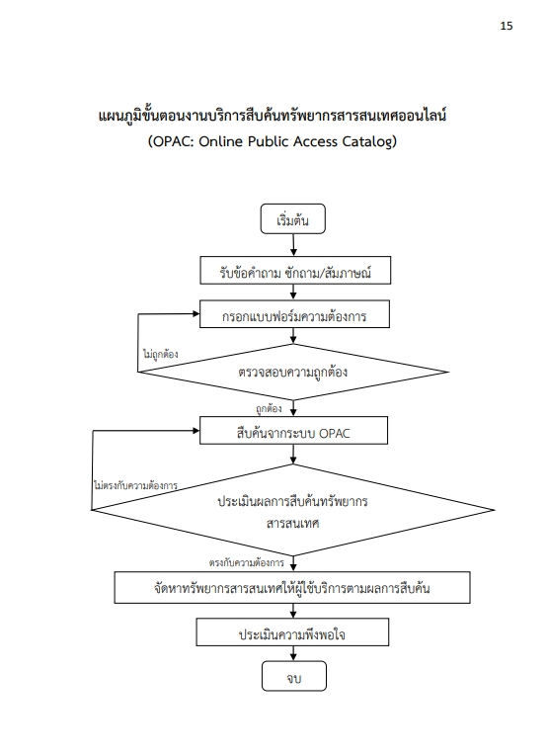

ตัวอย่าง Flow chart

อ้างอิงจากคู่มือปฏิบัติงานหลักงานบริการสืบค้นทรัพยากรสารสนเทศออนไลน์ มรภ.เทพสตรี

ขั้นตอนที่ 1............................................................................................................

วิธีการปฏิบัติงาน (ชี้แจง อธิบาย งานมีกฎ ระเบียบ กำหนดหลักเกณฑ์ไว้อย่างไร สรุปเป็นภาษาเขียนปฏิบัติงาน) ........................................................................................................................................................

.....................................................................................................................................................................

......................................................................................................................................................................

..................................................................................................................................................................... .....................................................................................................................................................................

......................................................................................................................................................................

.....................................................................................................................................................................

.....................................................................................................................................................................

......................................................................................................................................................................

.....................................................................................................................................................................

ปัญหาที่มักพบในการดำเนินงาน

........................................................................................................................................................

.....................................................................................................................................................................

......................................................................................................................................................................

..................................................................................................................................................................... .....................................................................................................................................................................

แนวทางแก้ไข

........................................................................................................................................................

.....................................................................................................................................................................

......................................................................................................................................................................

..................................................................................................................................................................... .....................................................................................................................................................................

ข้อเสนอแนะ

........................................................................................................................................................

.....................................................................................................................................................................

......................................................................................................................................................................

..................................................................................................................................................................... .....................................................................................................................................................................

ขั้นตอนที่ 2............................................................................................................

วิธีการปฏิบัติงาน (ชี้แจง อธิบาย งานมีกฎ ระเบียบ กำหนดหลักเกณฑ์ไว้อย่างไร สรุปเป็นภาษาเขียนปฏิบัติงาน) ........................................................................................................................................................

.....................................................................................................................................................................

......................................................................................................................................................................

..................................................................................................................................................................... .....................................................................................................................................................................

......................................................................................................................................................................

.....................................................................................................................................................................

.....................................................................................................................................................................

......................................................................................................................................................................

.....................................................................................................................................................................

ปัญหาที่มักพบในการดำเนินงาน

........................................................................................................................................................

.....................................................................................................................................................................

......................................................................................................................................................................

..................................................................................................................................................................... .....................................................................................................................................................................

แนวทางแก้ไข

........................................................................................................................................................

.....................................................................................................................................................................

......................................................................................................................................................................

..................................................................................................................................................................... .....................................................................................................................................................................

ข้อเสนอแนะ

........................................................................................................................................................

.....................................................................................................................................................................

......................................................................................................................................................................

..................................................................................................................................................................... .....................................................................................................................................................................

ขั้นตอนที่ 3............................................................................................................

วิธีการปฏิบัติงาน (ชี้แจง อธิบาย งานมีกฎ ระเบียบ กำหนดหลักเกณฑ์ไว้อย่างไร สรุปเป็นภาษาเขียนปฏิบัติงาน) ........................................................................................................................................................

.....................................................................................................................................................................

......................................................................................................................................................................

..................................................................................................................................................................... .....................................................................................................................................................................

......................................................................................................................................................................

.....................................................................................................................................................................

.....................................................................................................................................................................

......................................................................................................................................................................

.....................................................................................................................................................................

ปัญหาที่มักพบในการดำเนินงาน

........................................................................................................................................................

.....................................................................................................................................................................

......................................................................................................................................................................

..................................................................................................................................................................... .....................................................................................................................................................................

แนวทางแก้ไข

........................................................................................................................................................

.....................................................................................................................................................................

......................................................................................................................................................................

..................................................................................................................................................................... .....................................................................................................................................................................

ข้อเสนอแนะ

........................................................................................................................................................

.....................................................................................................................................................................

......................................................................................................................................................................

..................................................................................................................................................................... .....................................................................................................................................................................

ขั้นตอนที่ 4............................................................................................................

วิธีการปฏิบัติงาน (ชี้แจง อธิบาย งานมีกฎ ระเบียบ กำหนดหลักเกณฑ์ไว้อย่างไร สรุปเป็นภาษาเขียนปฏิบัติงาน) ........................................................................................................................................................

.....................................................................................................................................................................

......................................................................................................................................................................

..................................................................................................................................................................... .....................................................................................................................................................................

......................................................................................................................................................................

.....................................................................................................................................................................

.....................................................................................................................................................................

......................................................................................................................................................................

.....................................................................................................................................................................

ปัญหาที่มักพบในการดำเนินงาน

........................................................................................................................................................

.....................................................................................................................................................................

......................................................................................................................................................................

..................................................................................................................................................................... .....................................................................................................................................................................

แนวทางแก้ไข

........................................................................................................................................................

.....................................................................................................................................................................

......................................................................................................................................................................

..................................................................................................................................................................... .....................................................................................................................................................................

ข้อเสนอแนะ

........................................................................................................................................................

.....................................................................................................................................................................

......................................................................................................................................................................

..................................................................................................................................................................... .....................................................................................................................................................................

ขั้นตอนที่ 5............................................................................................................

วิธีการปฏิบัติงาน (ชี้แจง อธิบาย งานมีกฎ ระเบียบ กำหนดหลักเกณฑ์ไว้อย่างไร สรุปเป็นภาษาเขียนปฏิบัติงาน) ........................................................................................................................................................

.....................................................................................................................................................................

......................................................................................................................................................................

..................................................................................................................................................................... .....................................................................................................................................................................

......................................................................................................................................................................

.....................................................................................................................................................................

.....................................................................................................................................................................

......................................................................................................................................................................

.....................................................................................................................................................................

ปัญหาที่มักพบในการดำเนินงาน

........................................................................................................................................................

.....................................................................................................................................................................

......................................................................................................................................................................

..................................................................................................................................................................... .....................................................................................................................................................................

แนวทางแก้ไข

........................................................................................................................................................

.....................................................................................................................................................................

......................................................................................................................................................................

..................................................................................................................................................................... .....................................................................................................................................................................

ข้อเสนอแนะ

........................................................................................................................................................

.....................................................................................................................................................................

......................................................................................................................................................................

..................................................................................................................................................................... .....................................................................................................................................................................

ขั้นตอนที่ 6............................................................................................................

วิธีการปฏิบัติงาน (ชี้แจง อธิบาย งานมีกฎ ระเบียบ กำหนดหลักเกณฑ์ไว้อย่างไร สรุปเป็นภาษาเขียนปฏิบัติงาน) ........................................................................................................................................................

.....................................................................................................................................................................

......................................................................................................................................................................

..................................................................................................................................................................... .....................................................................................................................................................................

......................................................................................................................................................................

.....................................................................................................................................................................

.....................................................................................................................................................................

......................................................................................................................................................................

.....................................................................................................................................................................

ปัญหาที่มักพบในการดำเนินงาน

........................................................................................................................................................

.....................................................................................................................................................................

......................................................................................................................................................................

..................................................................................................................................................................... .....................................................................................................................................................................

แนวทางแก้ไข

........................................................................................................................................................

.....................................................................................................................................................................

......................................................................................................................................................................

..................................................................................................................................................................... .....................................................................................................................................................................

ข้อเสนอแนะ

........................................................................................................................................................

.....................................................................................................................................................................

......................................................................................................................................................................

..................................................................................................................................................................... .....................................................................................................................................................................

ขั้นตอนที่ 7............................................................................................................

วิธีการปฏิบัติงาน (ชี้แจง อธิบาย งานมีกฎ ระเบียบ กำหนดหลักเกณฑ์ไว้อย่างไร สรุปเป็นภาษาเขียนปฏิบัติงาน) ........................................................................................................................................................

.....................................................................................................................................................................

......................................................................................................................................................................

..................................................................................................................................................................... .....................................................................................................................................................................

......................................................................................................................................................................

.....................................................................................................................................................................

.....................................................................................................................................................................

......................................................................................................................................................................

.....................................................................................................................................................................

ปัญหาที่มักพบในการดำเนินงาน

........................................................................................................................................................

.....................................................................................................................................................................

......................................................................................................................................................................

..................................................................................................................................................................... .....................................................................................................................................................................

แนวทางแก้ไข

........................................................................................................................................................

.....................................................................................................................................................................

......................................................................................................................................................................

..................................................................................................................................................................... .....................................................................................................................................................................

ข้อเสนอแนะ

........................................................................................................................................................

.....................................................................................................................................................................

......................................................................................................................................................................

..................................................................................................................................................................... .....................................................................................................................................................................